
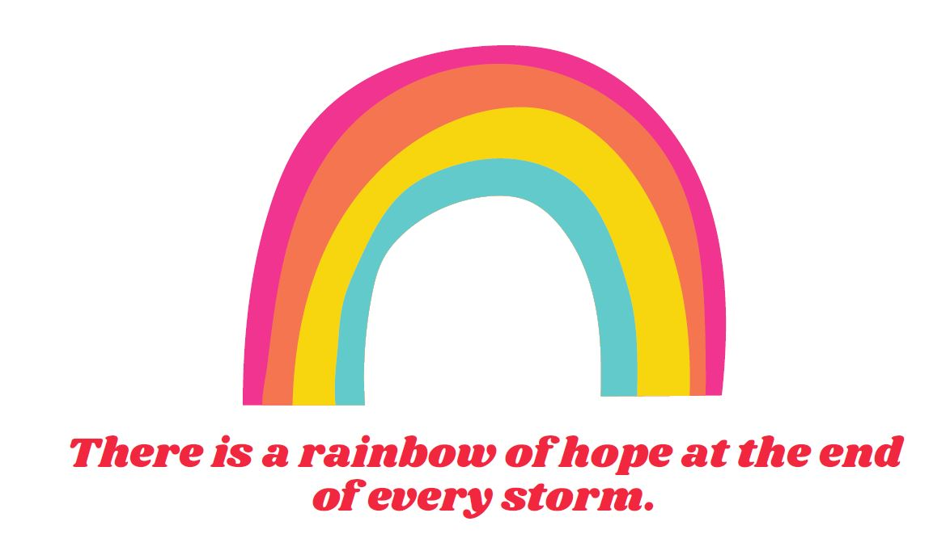

Top Tips & Practical Ideas for Maintaining Positive Emotional Well-Being

This guide has been produced with the help of Safe Space therapists, volunteer mentors and colleagues.

It includes a range of top tips, practical ideas and techniques, and engaging resources that you may find useful to help maintain and improve your emotional well-being during what is currently an undoubtedly difficult time for all.

For your ease the guide is sectioned by themes but be sure to take a look at all the different sections as you may find some ideas that you wouldn’t normally consider beneficial!
There may be other ideas not listed which you already find useful but hopefully there are a few new suggestions for you to try!

If you tried one of the ideas suggested and found it was helpful why not let us know on Twitter or Instagram?
 @SafeSpaceHerts
 @safespacehertfordshire

Sharing is caring so if you have a friend, family member or maybe even a neighbour you feel that would benefit from trying out some of the suggestions in this guide, be sure to pass on any of the tips or resources.
Top Tips, Practical Ideas, Techniques and Resources:
- Mindfulness; breathing techniques, colouring, grounding techniques

- Personal Care
- Creativity
- Spend Time with Loved Ones (near or far!)
- Keep Healthy; eat well, sleep, get moving!
- Gratitude and Kindness
- Limit your intake of the news
- Enjoy the Outdoors
- Staying well and healthy in your home

- Ask for Help; contact details, what to do in an emergency
- Mindfulness
Breathing Techniques: Mindful breathing has many different benefits for not just your mind but also your body. It can help reduce stress and anxiety, helps enhance emotion regulation and can even boost memory and concentration.
Try practicing these breathing techniques and see if you find them useful. It might take a few times to get them right and to feel the benefit but the more you practice the easier they’ll become!
Mindfulness Breathing Exercises
Elephant Breaths:Stand legs shoulder width apart, arms dangling in front of you like an Elephants trunk.
Take a deep breath in through your nose, raising your arms high above your head like an Elephant’s trunk. Hold for 2 to 3 seconds, release the breath through your mouth, lowering your arms back down. (repeat several times)
Bumble Bee Breaths: Sit crossed leg on the floor.
Put your fingers in your ears and breath in slowly through your nose.
Now hum as you exhale. (repeat several times)
Flower Breaths: 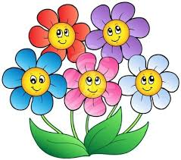Imagine smelling a beautiful flower.
Breath in through the nose, smelling the wonderful scent of the flower.
Hold for a second and breath out gently through your mouth. (repeat)
Hissing Breaths: Sit crossed leg on the floor.
Breath in through your nose and hold for 2 to 3 seconds.
Hiss out the breath like a snake. (repeat several times)

Hot air Balloon:  Sit crossed leg on the floor
Place your hands around your mouth, as if you were going to shout out to someone far away.
Take a deep breath and as you exhale move your hands and arms outward as if blowing up a giant balloon. Now breath normally swaying gently from side to side, watching your balloon fly higher and higher. (this requires you to visualise the balloon gently floating up and away)
Bear Breaths: Imagine a Bear hibernating and get into a comfortable position laying curled up on the floor.
Breath in for 4 seconds and out for 4 seconds, pause, breath in for 2 seconds and out for 2 seconds, pause. (repeat the sequence several times until you are relaxed and in hibernation)
Blowing Bubbles:  Buy or make a pot of bubbles. (And remember bubbles are not just for children!)
Breath in and gently blow, controlling the breath in order to blow the biggest bubble you can. The more you control the breath, the better bubbles you will get.
Rainbow Breaths:  Sit crossed legged with your hands on your knees.
Inhale through your nose, arching your back looking up to the sky.
Exhale, rounding your back to look down into your lap.
Repeat 7 times for each colour of the rainbow. Feel the energy gently flowing through your body.

Mindfulness Colouring: Colouring is a great mindfulness technique that really helps to relax your mind. By focusing on the task at hand your mind isn’t thinking about other things or any of your worries which helps you achieve a mindfulness state.
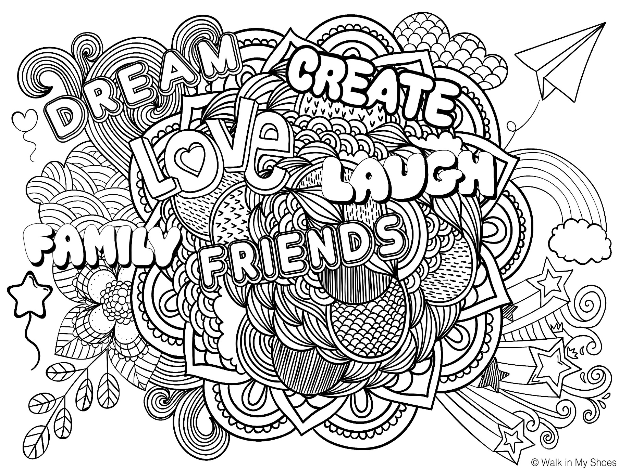
If you have a printer at home why don’t you print the below picture and colour it in? Don’t have a printer? No problem! Why not draw your own picture and then colour it in? There are also websites where you can colour in images online! Don’t forget to share your masterpieces with us on Twitter or Instagram!
If colouring isn’t your thing (hey we’re all individuals with different likes and interests!) there are lots of alternative activities you can try. Some of our other suggestions at Safe Space include:
- Puzzles; online or the cardboard kind!
- Online solitaire or other online card games
- Paint by numbers
- Sewing, crocheting or knitting
- Sudoku

Grounding Techniques: Grounding techniques can be used when you feel anxious and overwhelmed. They can also help if you are feeling an urge to self-harm. They help distract you from your current thoughts and worries to instead refocus on what’s happening in the present moment. The great thing about grounding techniques is that some can be super simple and discrete so you can use them wherever you are.
Why not give some of the following grounding techniques a go?
- Identify a Rainbow: Take a deep breath, look around you and identify something Red, Orange, yellow etc, for each colour of the rainbow.
- 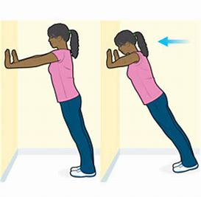 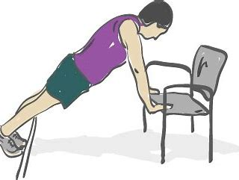Wall or chair push ups: stand arm’s length away from a wall or chair. Put your hands against the wall/chair, lean forward and push back. Repeat several times.
- 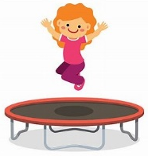Up and down exercises: bouncing up and down on a trampoline, space hopper or exercise ball. Jumping jacks, skipping, squats etc. up and down movements are grounding movements which help us to bring our energy levels back down.
- Heavy boxes: Put some heavy objects into a box and push the box around an obstacle course.
- Weighted backpack: put some books into a backpack to make it feel weighted (make sure the weight is appropriate to your size) and go for a walk.
- Hanging and swinging finding something to hang or swing from is a great way of stretching out the body and can be calming and grounding.
- Balancing: balancing on a balance board or using yoga exercises are a great way of using and developing the core muscles, they also encourage focus and attention.
- Use math and numbers: try running through a times table in your head or counting backward from 100.
- 5-4-3-2-1 method; Working backward from 5, use your senses to list things you notice around you. List 5 things you hear, 4 things you see, 3 things you can touch from where you’re sitting, 2 things you can smell, and 1 thing you can taste.
- A-B-C: Look around the room and name something you see that starts with the letter A, then B, C and so forth. See how far you can get through the alphabet.

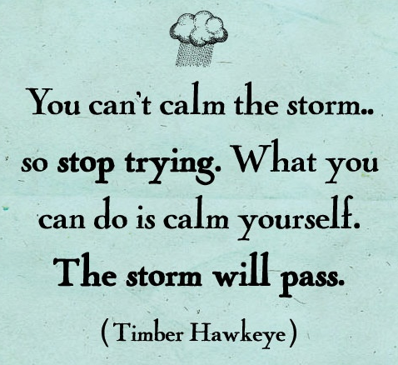

- Personal Care
When your normal routine is interrupted and if you are feeling particularly down and low in mood, it can be difficult to feel motivated to keep up with your personal hygiene and usual care routines. However it’s so important to maintain this when you can because it can really help your mood and the way you are feeling. So whilst it might be appealing to live in your pyjamas 24/7 make sure you are getting up and getting dressed properly… at least 6 days a week!
- Have a relaxing bath; bubbles, a bath bomb, a face mask, a book or some relaxing music!
- Why not treat yourself to an at home spa day? You could even rope in your family members at home or digitally connect with friends whilst you all have a pamper session!

- Paint your nails or see if someone else will let you paint theirs!
- Play around with make-up; watch some Youtube videos and get creative with colour you wouldn’t usually try?
- …just maybe don’t try cutting your own hair!

- Creativity
Why not use your spare time to get creative? It can be a great way to relax!
There are lots of different creative activities you can try from painting, drawing, sewing, crafting, cooking/baking, music, writing, upcycling and DIY, learning languages and gardening. You don’t have to be ‘good’ at any of these, it’s about finding something you enjoy! So what do you fancy trying?!
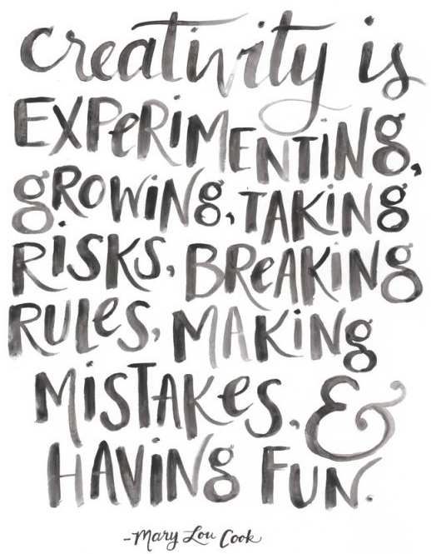

Why not try making a salt bottle, which is one activity some of our counsellors do in sessions (usually you use coloured sand but salt might be an ingredient you already have at home)
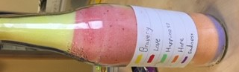
What do I need?
- Enough table salt to fill the bottle to the top.
- Chalk or art pastels, depends how bright you want your colour, pastels are better.
- Small funnel
- Empty bottle, with a screw top.
Method: Decide how many colours you need and what emotion each colour represents like blue could be sad, red happy, yellow angry etc. Next up you want to make your coloured salts by grinding your chalk or pastels into the salt until you have the hue you want (it’s easier if you colour the salt whilst on a piece of paper).
Now decide how big each emotion would be inside you now. Pour the coloured salts into the bottle one colour at a time using the funnel to the size of each emotion. Fill the bottle to the top so there is no room for the salt to muddle up. Fix the bottle shut.
Label your bottle so you know what colour represents what emotion. Do the emotions change from one day or week to the next?

Fancy baking but can’t get flour anywhere? How about trying this banana flapjack recipe:
Ingredients:
- 125g unsalted butter
- 2 tablespoons soft light brown sugar
- 5 tablespoons golden syrup
- 2 cups of oats
- 1 ripe banana
Method:
- Line a square tin with baking paper.
- Heat the butter, sugar and syrup in a pan until melted.
- Add the oats and mashed up banana and mix well.
- Pour into the tin and flatten mixture down.
- Put in the oven and cook for 15 to 20 minutes until golden brown.
- Cut into squares whilst still warm. Then enjoy!
"You can’t use up creativity. The more you use, the more you have."
- Maya Angelou
Why not make a COVID-19 time capsule?
With the current situation being something most of us across the world have never experienced before (and hopefully it’s something we don’t encounter again) why not document history and make a time capsule all about COVID-19 and your experience. It could be pretty interesting for future generations to unearth one day!
Why not include information such as:
- Detail what’s currently going on
- How you’re feeling about everything
- List what you’ve been doing whilst at home
- Write a letter to your future self
- Interview a family member or friend about their experience and feelings
- How your local community has adapted



- Spend Time with Loved Ones
Although we might not be able to be physically as close to our loved ones at the moment, it is important to keep in touch.

There are lots of different apps you can access to have digital face to face contact with your friends and family. How about trying out some of the below ideas on your next catch up?
- Quizzes; each individual/household makes up a round or two or you could be the quizmaster and host a quiz for everyone!
- How about starting a digital book club?
- Grab a cuppa and have a virtual coffee morning!
- Virtual dance party; pick your favourite songs and get moving!
- Why not cook or bake along together? You could learn a new recipe!
Why don’t you also take this time to get in touch with someone you’ve been meaning to catch up with?
If you are at home with parents/carers, siblings or other family members take this opportunity to spend some quality time together, perhaps playing board games, watching films/TV together or just sitting and having a chat! How often do we get to have this amount of time, at a slower pace of life with no school or everyday life responsibilities to spend with our loved ones?
"Sometimes your joy is the source of your smile, but sometimes your smile can be the source of your joy."
- Thich Nhat Hanh

- Keep Healthy
Eat well; Whilst it’s tempting to eat all your home baked goods (if they last more than a day in your house share your secrets!) it’s important to try and maintain a healthy balanced diet and keep hydrated. Eating well is not only good for your physical health and your immune system it’s also beneficial for your mental health and well-being. It’s been shown that having a healthy, varied and balanced diet can not only give you more energy but can also improve your mood which we all need at the moment. And don’t forget to drink plenty of water!
Why not give this ‘pick me up’ energy smoothie a go?
- x2 big handfuls of fresh spinach leaves (washed)
- x5 strawberries (washed)
- x1 banana
- 100 ml apple juice (or coconut water)
- Blend all the ingredients in a blender or a smoothie maker (be careful!)
- Pour contents into a tall glass and enjoy

Sleep well; With a change to your usual routine and no school or after school clubs or activities, it’s easy to find yourself staying up much later than you normally would meaning you could be losing out on several hours sleep each night. Sleep is super important, particularly for young people as it helps you grow, can improve your concentration and also helps with your mood. If you’re going to bed in the early hours of the morning and then waking up late morning or even midday, you may find yourself feeling unmotivated which can further lower your mood. Try and go to bed at a reasonable time during the week and leave the late nights for the weekend!
Equally you may find that you feel more tired than you normal are and there’s an interesting explanation behind this. Usually your brain knows what you’ll be doing next in your day to day routine meaning it can ‘switch off’. However with the current situation and everything being different to normal, our brains are now using more energy as we have to subconsciously make more decisions meaning our brains are working overtime because we’re having to think more. So whilst it might feel like you’re doing less than normal and therefore you should have more energy, remember our brains are doing more and this can be tiring.

Get moving; You don’t have to be running marathons and making an at home gym in order to keep fit. Just get up and get moving in whatever way you feel comfortable and able to do so. Make it fun and do what you enjoy; whether that’s going for a bike ride, smashing your personal best on a run, going for a quiet walk, gardening, or dancing round your living room like nobody’s watching, because when it’s something you enjoy doing you’ll want to do it and it’s a lot easier to stick to it!
Stuck for ideas on how to get moving? How about giving the following ‘boredom buster workout’ activity a go?

Create your own Boredom Buster Workout!
Come up with different actions for each letter of the alphabet and then spell your full name by picking the actions next to each letter. Why not challenge someone else at home to have a go or set the actions for you!
Here are a few suggestions to help get you started;
A – Do 20 star jumps 
B – Walk like a ballerina for the count of 10 
C- With your hands on the floor, walk sideways like a crab around the room 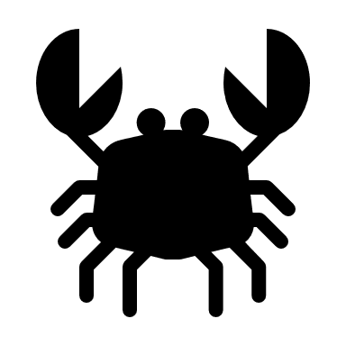
D- Dance like you are on the moon  
E- Reach for the clouds and hold for the count of 15 
F- Fly like a bird for the count of 20 

Managing Stress; You may be feeling more stressed than usual at the moment and that is to be expected due to the change and uncertainty currently being experienced. However it is important to try and mange your stress levels where you can to ensure you do not become too overwhelmed.
The stress bucket activity is a great way to reassess your stress factors and the ways in which you can manage how you are feeling to try and ease your worries. Think of the clouds and rain as containing all of your stresses, this could be; school work, health problems, home life, change in routine etc. If you let these worries build up soon your bucket will be full and start to overflow (which we don’t want to happen!). That’s why we need to have healthy ways we can release some of these worries through the tap in our bucket. In the water droplets below the bucket, write ways you can manage your stresses so your bucket doesn’t overflow. These could be; talking to someone, watching your favourite movie, listening to music, going for a walk etc.

Why not give it a go below or you could even draw your own stress bucket, it’s really easy to do!

My Stress Bucket

- Gratitude and Kindness
Gratitude Jar
‘Gratitude is the quality of being thankful’; in difficult times like we’re experiencing now it can bring a chance to reflect on the small and big things we feel grateful for in our lives. Gratitude can help relieve stress, make you feel happier and also improve your self-esteem.
A great way to practice gratitude every day is a gratitude jar:
You’ll need a jar or a box (anything you can use to store your gratitude statements in!), some paper and a pen!
Write down three gratitude statements on three separate slips of paper; a gratitude statement acknowledges something that a person appreciates or is thankful for.
Some examples of statements
“Something I look forward to every day is…”
“I am thankful for my brother who is always there for me when I feel down.”
“Something that made me smile today was…”
“I appreciate my teachers because they always want the best for me.”
“I am grateful I am able to spend time with my family.”
Each day try and write down another three statements and add them to your jar. Once your jar is full you could then try picking one slip of paper out a day and spend some time reflecting on your gratitude statement.
You could even decorate your jar or box to make it personal to you.
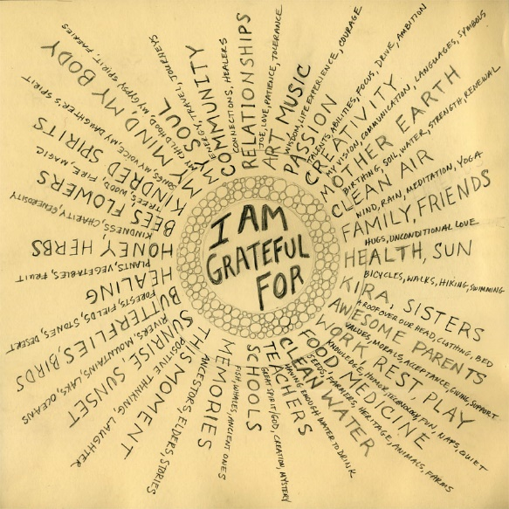

Make a ‘post lockdown’ to-do list
Write down on small pieces of paper lots of different things and activities you would like to do by yourself or with friends and family once it is safe to do so. Fold up all your ideas and place them in a jar. Then when some level of normality resumes, once a week pick out a piece of paper and get going!
Maybe you’d like to go to the cinema, have a picnic, go shopping with your friends, visit somewhere new.
Having fun things to look forward to can help you keep a positive mindset as well as reminding you that this is temporary and one day things will be ‘normal’ and we’ll all be able to return to doing all the things we enjoy with our loved ones.

- Limit your intake of the news
Whilst social media is a great tool to help you keep in touch with your loved ones and peers, as well as staying up to date with the goings-on in the World, it can also be at times overwhelming and have a negative impact on your mental health and well-being, especially if you are already feeling anxious by the current situation.
Try and limit your interaction with news outlets and social media each day. Perhaps just listen to/read about the news once a day or maybe every other day. See if you can avoid going on social media right before bed as it can impact your ability to get to sleep as well as the quality of your sleep.
If you’re finding it difficult to practice limiting your time, try having a day off your phone by putting it in a draw or box one day a week – a digital detox! Leave your phone in a different room overnight so you’re not tempted or distracted by it going off from messages and notifications.
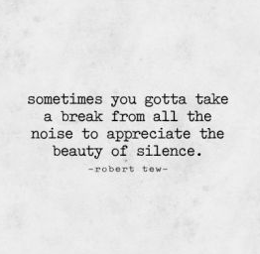

- Enjoy the Outdoors
If you have a garden be sure to make good use of it and enjoy the fresh air and any good weather we have! Sunshine is good for the soul!
If you don’t have a garden can you try and make use of the outside space local to you – are there any large open spaces such as fields or parks that are safe to walk around using your daily exercise time?
If you are unable to or don’t feel like going outside, try just opening a window to allow some fresh air in. It can be really peaceful to hear the birds outside and hearing noise coming from other homes and the outside world can help remind you that you are not alone in this situation.
When outside or sitting by a window use your senses to notice what you can see, what you can hear, smell and possibly even touch. This can be a great way to ground yourself if you’re feeling anxious.
"It’s ok to feel ‘up and down.’ The weather does that too, but we need every season and each one is beautiful and important.”

- Staying Well and Healthy in your Home
Routine; try and stick to a routine that gives you a sense of ‘normal’. Whilst it might not be possible to maintain your usual routine, it is important for your mental health and well-being to try and engage in some kind of routine that gives you structure and a focus. If you’re feeling anxious, writing down a routine can be beneficial as it can help you feel in control.
Why not write out your own routine like the following example?
9am Wake up, shower & breakfast
10am School work
12pm Lunch
1pm Daily walk for some fresh air
3pm Creative time
5pm Facetime catch up with friends
7pm Dinner
9pm Netflix
10pm Bed
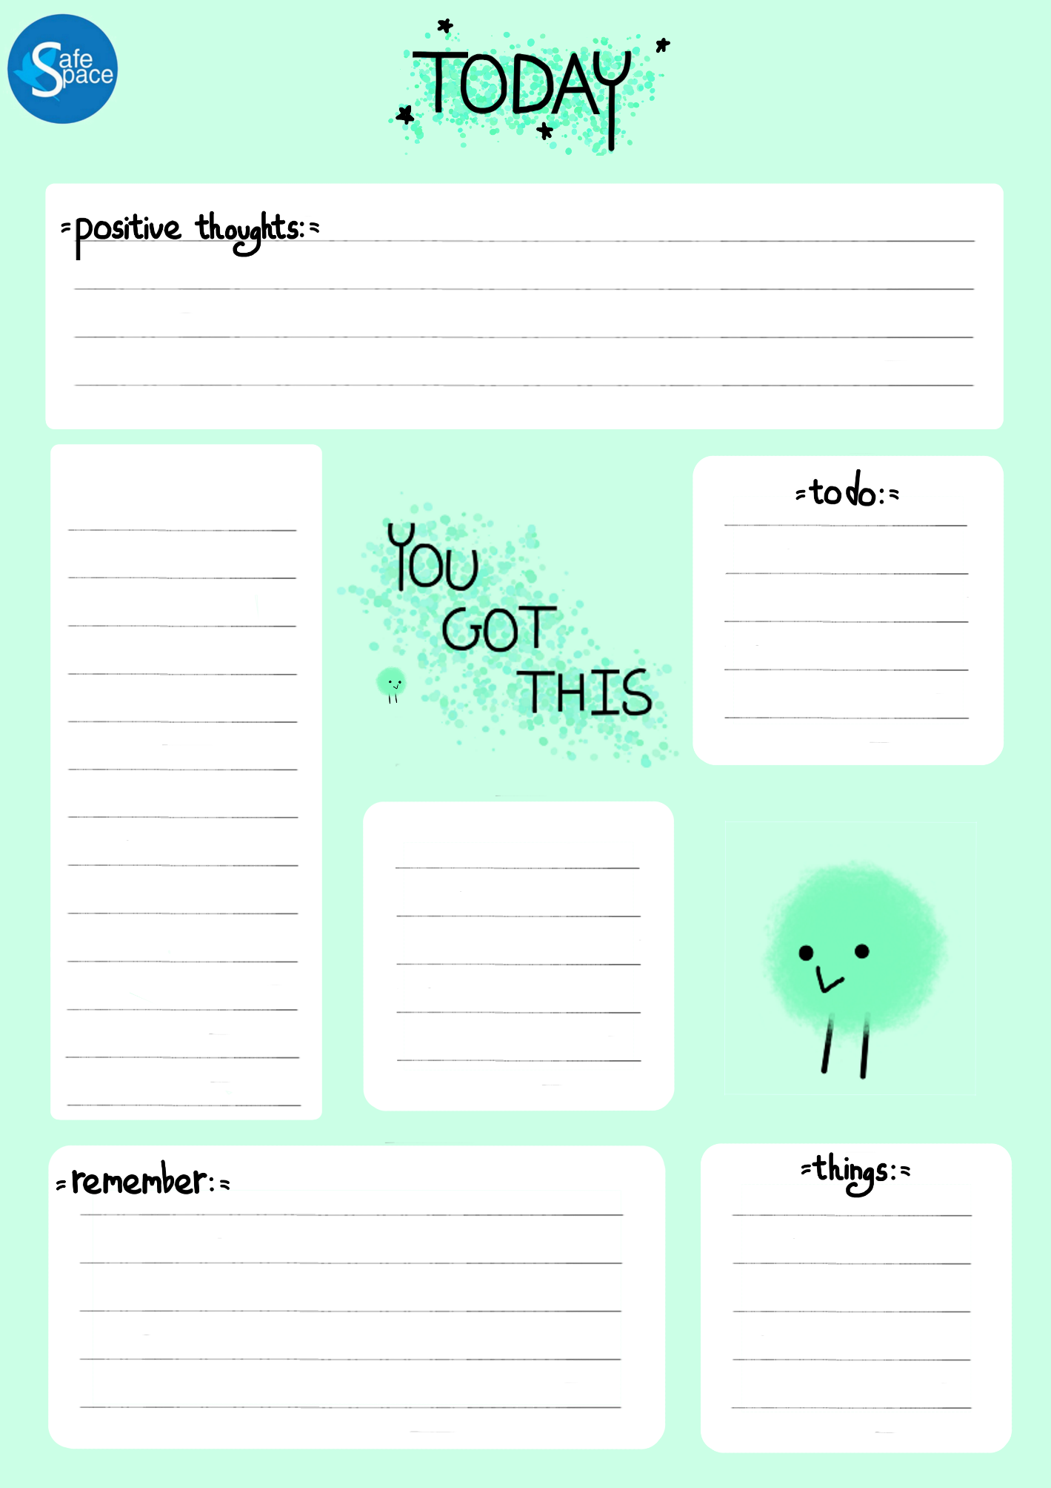
If you find it difficult to keep some structure to your day why not use the following ‘today’ sheet to help you plan your day and keep you motivated?
Scenery; it can be really difficult spending lots of time in just one place so if you are able to, try and make sure you switch up your location within your home and don’t just spend all your time in one room in the same spot.
Language; although it is a difficult and upsetting time at the moment one way you can try and maintain positive well-being is by trying to avoid using ‘negative’ language. Instead of saying ‘stuck at home’ try and say ‘safe at home’. Rather than ‘now I can’t go to this event’ why not think of it as ‘I can’t go to this event as I planned but I can go in the future when it’s safe to do so’.
Environment; they say ‘tidy space tidy mind’ so why not use this extra time at home to have a spring clean of your room or other spaces in your home? Clear out your wardrobe, organise your make-up, clean your trainers ready for when you can wear them out and about! You could also have a digital tidy up; delete old emails, sort the photos on your phone, update your playlists.


- Ask for Help
Talking to others about how you are feeling is always really important for your mental health and well-being but especially when we find ourselves in unusual and worrying circumstances. By talking to other people whether that be face to face with people in your home or digitally with friends and other family members, you can get things of your chest and share your worries. You might also find that somebody else is feeling the same way as you and that can be comforting to know you’re not alone with how you are feeling.
The current situation we find ourselves in is not a normal scenario and for most of us we’ve never experienced anything like this before so don’t put pressure on yourself or be too upset if some days you feel a bit down and sad. You’re not alone with how you are feeling and it’s okay to acknowledge when you’re having a tough time. Also don’t dismiss how you feel even if you feel other people are currently having a harder time. You’re allowed to be upset about the birthday party you had planned not going ahead as you hoped as much as somebody else can be upset about a loved one being poorly. Your feelings are valid no matter your circumstances.
If you feel you are unable to talk to someone at home or to a friend there are lots of services, organisations and charities who are still offering support if you need it:
- Kooth: https://www.kooth.com/ provides free online support Monday – Friday 12pm – 10pm and Saturday – Sunday 6pm – 10pm.

- Childline: If you're under 19 you can confidentially call on 0800 1111 and speak to a counsellor from 9am – midnight.

- YoungMinds Crisis Messenger provides free, 24/7 crisis support across the UK if you are experiencing a mental health crisis. If you need urgent help text YM to 85258.

- Samaritans: You can call the Samaritans 24/7 on 116 123.
Emergency Support for Children & Young People
In Hertfordshire if you, a friend or family member are experiencing a mental health crisis call 0300 777 0707 in the first instance. If you need medical or physical health treatment in an emergency (for example from self-harm) go to your nearest A&E department or call 999 (correct as of 14th May 2020).


